C-Media CM6631A/ CM6601A/ CM6632A
USB 2.0 Controller
Firmware Specification

C-MEDIA Electronics Inc.

Revision History

Revision | Date | Description
1.0 | 2012/07/11 | Initial version
1.1 | 2012/08/14 | Add CM6601A and CM6632A firmware spec.
1.2 | 2013/04/09 | Modify the codec description for new demo board.
1.3 | 2014/12/03 | Add microphone gain control and boost control

Contents

1. Introduction 4
2. Features 4
3. Audio 2.0 Device of CM6631A and CM6632A 6
3.1. CM6631A Audio Topology 6
3.2. CM6632A Audio Topology 7
3.3. USB Interface List 8
3.4. High Speed Audio Stream Alternate Setting List of CM6631A 8
3.5. High Speed Audio Stream Alternate Setting List of CM6632A 9
3.6. Full Speed Audio Stream Alternate Setting List 10
4. Audio 1.0 Device of CM6631A and CM6632A 11
4.1. CM6631A Audio Topology 11
4.2. CM6632A Audio Topology 12
4.3. USB Interface List 13
4.4. High Speed Audio Stream Alternate Setting List of CM6631A 13
4.5. High Speed Audio Stream Alternate Setting List of CM6632A 14
4.6. Full Speed Audio Stream Alternate Setting List 15
5. Audio 1.0 Device of CM6601A 16
5.1. Audio Topology 16
5.2. USB Interface List 16
5.3. High Speed Audio Stream Alternate Setting List 17
5.4. Full Speed Audio Stream Alternate Setting List 17

Introduction
This document describes the firmware specification of the USB audio device by CM6631A, CM6601A and CM6632A. The specification described here doesn’t mean all the features of the chips. It only describes the specification of the application.

Features
The firmware features of CM6631A, CM6601A and CM6632A are listed below.
- The clock of MCU 8051 is 48MHz.
- CM6632A supports 8-channel speaker. CM6631A and CM6601A supports only 2-channel speaker.
- Supports USB 2.0 high-speed and full-speed operation. The operation speed depends on speed of bus.
- CM6631A and CM6632A support both USB audio class 1.0 and 2.0. The device is an audio 2.0 device when the pin GPI-4 is high, audio 1.0 device when GPI-4 is low.
- CM6601A only supports USB audio class 1.0.
- The audio 2.0 devices of CM6631A and CM6632A support sampling rate 44100, 48000, 88200, 96000, 176400, 192000 Hz, and bit resolution 16-, 24-bit.
- In these applications, the sampling rate 8000, 16000, 32000, 44100, 48000, 64000, 88200, 96000 are implemented for audio 1.0 device.
- Supports USB MIDI class 1.0. Supports one MIDI-in and one MIDI-out ports.
- Supports USB HID class 1.1. User can access registers via HID input report and output report.
- Supports buttons of volume-up, volume-down, mute-play and mute-record.
- Supports LEDs of status, mute-play and mute-record. Status LED will blink in 30ms interval if any playback is active.
- The device is self-powered device. Maximum current drawn from bus is 100mA.
- Supports both I2S and S/PDIF audio interfaces.
- The codecs in these applications are listed below.

6631A | Speaker | PCM1792
6631A | Headphone | WM8741
6631A | Line in | CS5381
6631A | Microphone | CS5346
6632A | Speaker | CS4382
6632A | Headphone | CS4398
6632A | Line in | CS5381
6632A | Microphone | CS5346

- The I2S clocks’ ratio generated for codecs are listed below.

PCM1792, WM8741, CS4382, CS4398
LRCK | 8000 ~ 48000 Hz | 64000 ~ 96,000 Hz | 176400 , 192000 Hz
BCLK | LRCK*128 | LRCK*64 | LRCK*64
MCLK | LRCK*256 | LRCK*256 | LRCK*128

CS5381
LRCK | 8000 ~ 48000 Hz | 64000 ~ 96,000 Hz | 176400 , 192000 Hz
BCLK | LRCK*64 | LRCK*64 | LRCK*64
MCLK | LRCK*256 | LRCK*256 | LRCK*128

CS5346
LRCK | 8000 ~ 48000 Hz | 64000 ~ 96,000 Hz | 176400 , 192000 Hz
BCLK | LRCK*64 | LRCK*64 | LRCK*64
MCLK | LRCK*256 | LRCK*128 | LRCK*128

Audio 2.0 Device of CM6631A and CM6632A

CM6631A Audio Topology
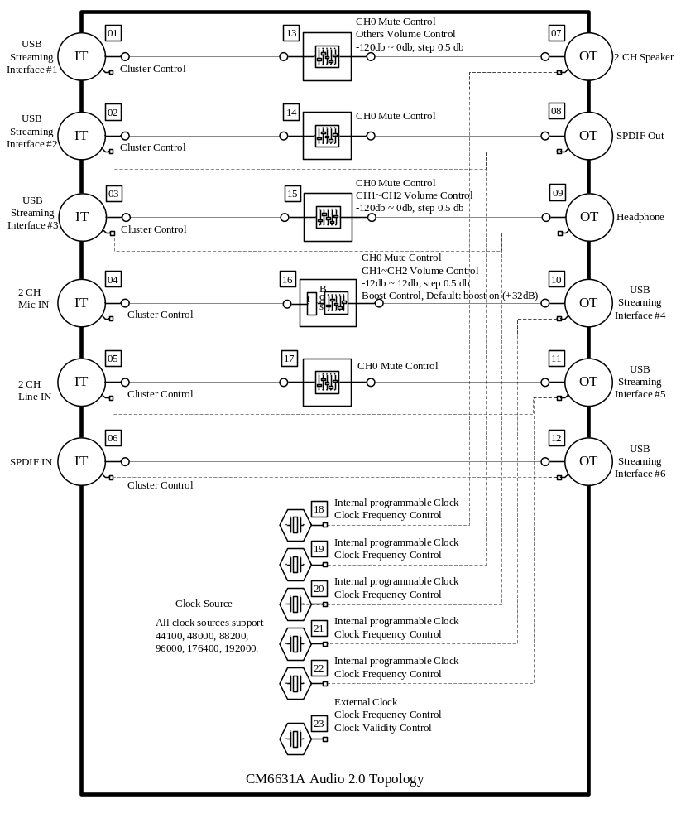

CM6632A Audio Topology
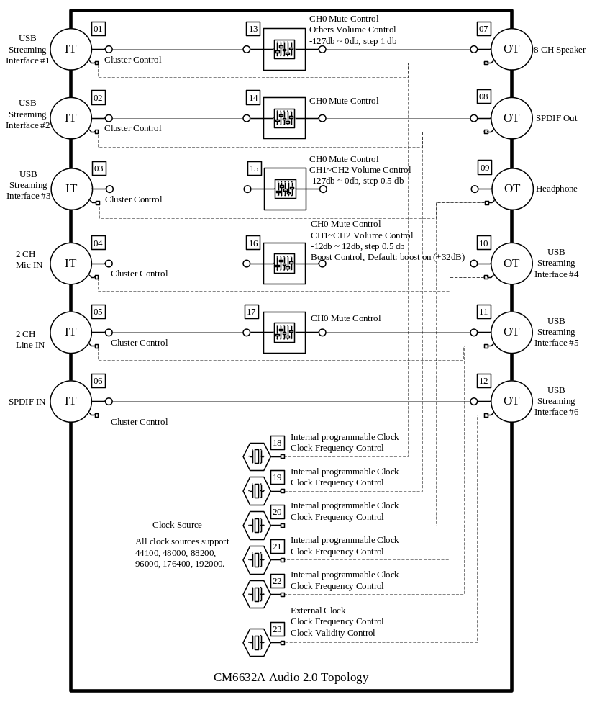

USB Interface List

 | Interface Description | Endpoint
Interface 0 | Audio Control Interface of Audio Device | 0x8F(Interrupt In 6 bytes)
Interface 1 | Audio Stream Interface for Speaker | 0x05, 0x85(Feedback Endpoint)
Interface 2 | Audio Stream Interface for SPDIF Out | 0x06, 0x86(Feedback Endpoint)
Interface 3 | Audio Stream Interface for Headphone | 0x07, 0x87(Feedback Endpoint)
Interface 4 | Audio Stream Interface for MIC In | 0x89
Interface 5 | Audio Stream Interface for Line In | 0x88
Interface 6 | Audio Stream Interface for SPDIF In | 0x8A
Interface 7 | HID Interface | 0x84(Interrupt In 16 bytes)
Interface 8 | Audio Control Interface of MIDI Device
Interface 9 | MIDI Stream Interface | 0x01(Bulk Out), 0x82(Bulk In)

High Speed Audio Stream Alternate Setting List of CM6631A

 | Alternate | Data Format | Sampling Rate
Interface 1  (Speaker) | 1 | 2CH, 16Bits PCM | 44100, 48000, 88200, 96000, 176400, 192000
Interface 1  (Speaker) | 2 | 2CH, 24Bits PCM | 44100, 48000, 88200, 96000, 176400, 192000
Interface 2  (SPDIF Out) | 1 | 2CH, 16Bits PCM | 44100, 48000, 88200, 96000, 176400, 192000
Interface 2  (SPDIF Out) | 2 | 2CH, 24Bits PCM | 44100, 48000, 88200, 96000, 176400, 192000
Interface 2  (SPDIF Out) | 3 | 2CH, 16Bits AC3 | 44100, 48000, 88200, 96000, 176400, 192000
Interface 3  (Headphone) | 1 | 2CH, 16Bits PCM | 44100, 48000, 88200, 96000, 176400, 192000
Interface 3  (Headphone) | 2 | 2CH, 24Bits PCM | 44100, 48000, 88200, 96000, 176400, 192000
Interface 3  (Headphone) | 3 | 2CH, 32Bits PCM | 44100, 48000, 88200, 96000, 176400, 192000
Interface 4  (MIC In) | 1 | 2CH, 16Bits PCM | 44100, 48000, 88200, 96000, 176400, 192000
Interface 4  (MIC In) | 2 | 2CH, 24Bits PCM | 44100, 48000, 88200, 96000, 176400, 192000
Interface 5  (Line In) | 1 | 2CH, 16Bits PCM | 44100, 48000, 88200, 96000, 176400, 192000
Interface 5  (Line In) | 2 | 2CH, 24Bits PCM | 44100, 48000, 88200, 96000, 176400, 192000
Interface 6  (SPDIF In) | 1 | 2CH, 16Bits PCM | 44100, 48000, 88200, 96000, 176400, 192000
Interface 6  (SPDIF In) | 2 | 2CH, 24Bits PCM | 44100, 48000, 88200, 96000, 176400, 192000

High Speed Audio Stream Alternate Setting List of CM6632A

 | Alternate | Data Format | Sampling Rate
Interface 1  (Speaker) | 1 | 2CH, 16Bits PCM | 44100, 48000, 88200, 96000, 176400, 192000
Interface 1  (Speaker) | 2 | 2CH, 24Bits PCM | 44100, 48000, 88200, 96000, 176400, 192000
Interface 1  (Speaker) | 3 | 4CH, 16Bits PCM | 44100, 48000, 88200, 96000, 176400, 192000
Interface 1  (Speaker) | 4 | 4CH, 24Bits PCM | 44100, 48000, 88200, 96000, 176400, 192000
Interface 1  (Speaker) | 5 | 6CH, 16Bits PCM | 44100, 48000, 88200, 96000, 176400, 192000
Interface 1  (Speaker) | 6 | 6CH, 24Bits PCM | 44100, 48000, 88200, 96000, 176400, 192000
Interface 1  (Speaker) | 7 | 8CH, 16Bits PCM | 44100, 48000, 88200, 96000, 176400, 192000
Interface 1  (Speaker) | 8 | 8CH, 24Bits PCM | 44100, 48000, 88200, 96000, 176400, 192000
Interface 2  (SPDIF Out) | 1 | 2CH, 16Bits PCM | 44100, 48000, 88200, 96000, 176400, 192000
Interface 2  (SPDIF Out) | 2 | 2CH, 24Bits PCM | 44100, 48000, 88200, 96000, 176400, 192000
Interface 2  (SPDIF Out) | 3 | 2CH, 16Bits AC3 | 44100, 48000, 88200, 96000, 176400, 192000
Interface 3  (Headphone) | 1 | 2CH, 16Bits PCM | 44100, 48000, 88200, 96000, 176400, 192000
Interface 3  (Headphone) | 2 | 2CH, 24Bits PCM | 44100, 48000, 88200, 96000, 176400, 192000
Interface 4  (MIC In) | 1 | 2CH, 16Bits PCM | 44100, 48000, 88200, 96000, 176400, 192000
Interface 4  (MIC In) | 2 | 2CH, 24Bits PCM | 44100, 48000, 88200, 96000, 176400, 192000
Interface 5  (Line In) | 1 | 2CH, 16Bits PCM | 44100, 48000, 88200, 96000, 176400, 192000
Interface 5  (Line In) | 2 | 2CH, 24Bits PCM | 44100, 48000, 88200, 96000, 176400, 192000
Interface 6  (SPDIF In) | 1 | 2CH, 16Bits PCM | 44100, 48000, 88200, 96000, 176400, 192000
Interface 6  (SPDIF In) | 2 | 2CH, 24Bits PCM | 44100, 48000, 88200, 96000, 176400, 192000

Full Speed Audio Stream Alternate Setting List

 | Alternate | Data Format | Sampling Rate
Interface 1  (Speaker) | 1 | 2CH, 16Bits PCM | 44100, 48000
Interface 2  (SPDIF Out) | 1 | 2CH, 16Bits PCM | 44100, 48000
Interface 2  (SPDIF Out) | 2 | 2CH, 16Bits AC3 | 44100, 48000
Interface 3  (Headphone) | 1 | 2CH, 16Bits PCM | 44100, 48000
Interface 4  (MIC In) | 1 | 2CH, 16Bits PCM | 44100, 48000
Interface 5  (Line In) | 1 | 2CH, 16Bits PCM | 44100, 48000
Interface 6  (SPDIF In) | 1 | 2CH, 16Bits PCM | 44100, 48000

Audio 1.0 Device of CM6631A and CM6632A

CM6631A Audio Topology

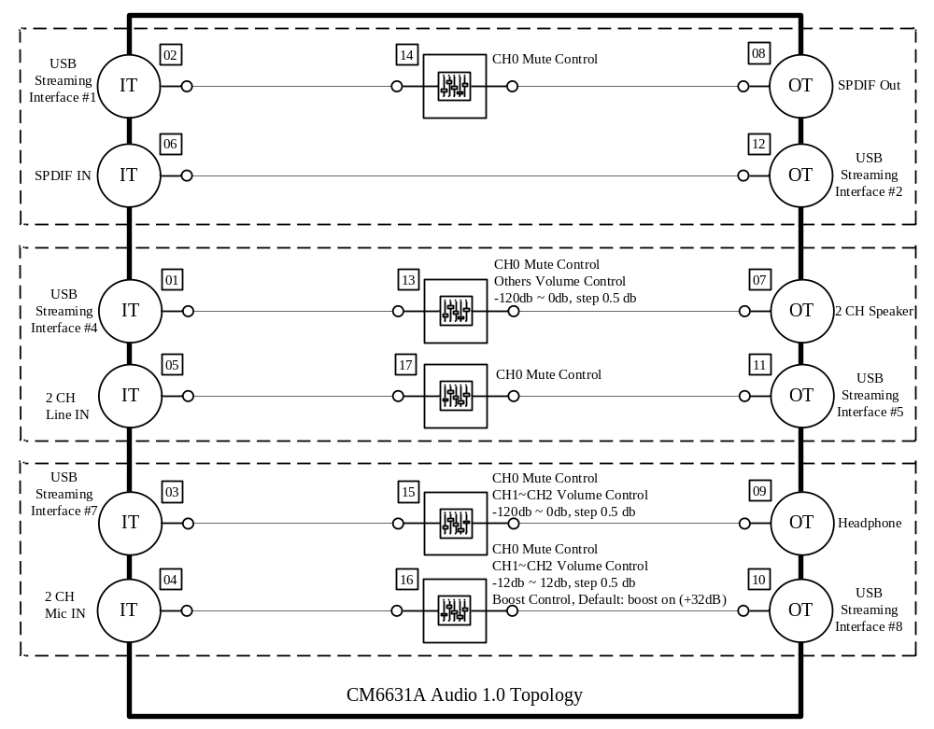

CM6632A Audio Topology

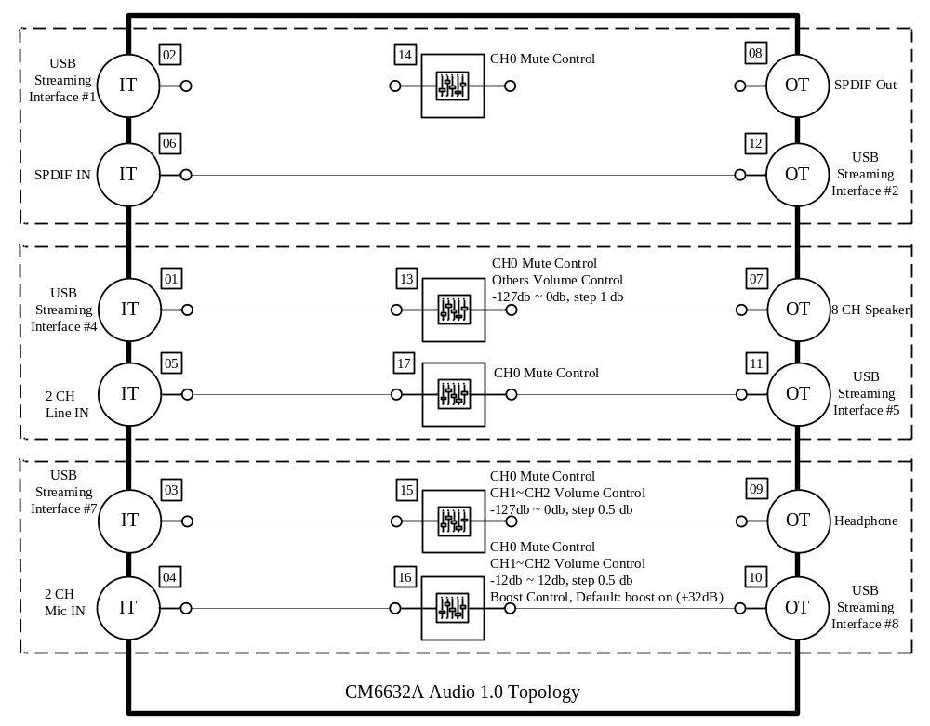

USB Interface List
 | Interface Description | Endpoint
Interface 0 | Audio Control Interface of Audio Device
Interface 1 | Audio Stream Interface for SPDIF Out | 0x06, 0x86(Feedback Endpoint)
Interface 2 | Audio Stream Interface for SPDIF In | 0x8A
Interface 3 | Audio Control Interface of Audio Device
Interface 4 | Audio Stream Interface for Speaker | 0x05, 0x85(Feedback Endpoint)
Interface 5 | Audio Stream Interface for Line In | 0x88
Interface 6 | Audio Control Interface of Audio Device
Interface 7 | Audio Stream Interface for Headphone | 0x07, 0x87(Feedback Endpoint)
Interface 8 | Audio Stream Interface for MIC In | 0x89
Interface 9 | HID Interface | 0x84(Interrupt In 16 bytes)
Interface 10 | Audio Control Interface of MIDI Device
Interface 11 | MIDI Stream Interface | 0x01(Bulk Out), 0x82(Bulk In)

High Speed Audio Stream Alternate Setting List of CM6631A
 | Alternate | Data Format | Sampling Rate
Interface 1  (SPDIF Out) | 1 | 2CH, 16Bits PCM | 32000, 44100, 48000, 88200, 96000
Interface 1  (SPDIF Out) | 2 | 2CH, 24Bits PCM | 32000, 44100, 48000, 88200, 96000
Interface 1  (SPDIF Out) | 3 | 2CH, 16Bits AC3 | 32000, 44100, 48000, 88200, 96000
Interface 2  (SPDIF In) | 1 | 2CH, 16Bits PCM | 32000, 44100, 48000
Interface 4  (Speaker) | 1 | 2CH, 16Bits PCM | 8000, 16000, 32000, 44100, 48000, 64000, 88200, 96000
Interface 4  (Speaker) | 2 | 2CH, 24Bits PCM | 8000, 16000, 32000, 44100, 48000, 64000, 88200, 96000
Interface 5  (Line In) | 1 | 2CH, 16Bits PCM | 8000, 16000, 32000, 44100, 48000, 64000, 88200, 96000
Interface 5  (Line In) | 2 | 2CH, 24Bits PCM | 8000, 16000, 32000, 44100, 48000, 64000, 88200, 96000
Interface 7  (Headphone) | 1 | 2CH, 16Bits PCM | 8000, 16000, 32000, 44100, 48000, 64000, 88200, 96000
Interface 7  (Headphone) | 2 | 2CH, 24Bits PCM | 8000, 16000, 32000, 44100, 48000, 64000, 88200, 96000
Interface 8  (MIC In) | 1 | 2CH, 16Bits PCM | 8000, 16000, 32000, 44100, 48000

High Speed Audio Stream Alternate Setting List of CM6632A

 | Alternate | Data Format | Sampling Rate
Interface 1  (SPDIF Out) | 1 | 2CH, 16Bits PCM | 32000, 44100, 48000, 88200, 96000
Interface 1  (SPDIF Out) | 2 | 2CH, 24Bits PCM | 32000, 44100, 48000, 88200, 96000
Interface 1  (SPDIF Out) | 3 | 2CH, 16Bits AC3 | 32000, 44100, 48000, 88200, 96000
Interface 2  (SPDIF In) | 1 | 2CH, 16Bits PCM | 32000, 44100, 48000
Interface 4  (Speaker) | 1 | 2CH, 16Bits PCM | 8000, 16000, 32000, 44100, 48000
Interface 4  (Speaker) | 2 | 4CH, 16Bits PCM | 8000, 16000, 32000, 44100, 48000
Interface 4  (Speaker) | 3 | 6CH, 16Bits PCM | 8000, 16000, 32000, 44100, 48000
Interface 4  (Speaker) | 4 | 8CH, 16Bits PCM | 8000, 16000, 32000, 44100, 48000
Interface 5  (Line In) | 1 | 2CH, 16Bits PCM | 8000, 16000, 32000, 44100, 48000, 64000, 88200, 96000
Interface 5  (Line In) | 2 | 2CH, 24Bits PCM | 8000, 16000, 32000, 44100, 48000, 64000, 88200, 96000
Interface 7  (Headphone) | 1 | 2CH, 16Bits PCM | 8000, 16000, 32000, 44100, 48000, 64000, 88200, 96000
Interface 7  (Headphone) | 2 | 2CH, 24Bits PCM | 8000, 16000, 32000, 44100, 48000, 64000, 88200, 96000
Interface 8  (MIC In) | 1 | 2CH, 16Bits PCM | 8000, 16000, 32000, 44100, 48000

Full Speed Audio Stream Alternate Setting List

 | Alternate | Data Format | Sampling Rate
Interface 1  (SPDIF Out) | 1 | 2CH, 16Bits PCM | 44100, 48000
Interface 1  (SPDIF Out) | 2 | 2CH, 24Bits PCM | 44100, 48000
Interface 1  (SPDIF Out) | 3 | 2CH, 16Bits AC3 | 44100, 48000
Interface 2  (SPDIF In) | 1 | 2CH, 16Bits PCM | 44100, 48000
Interface 4  (Speaker) | 1 | 2CH, 16Bits PCM | 44100, 48000
Interface 4  (Speaker) | 2 | 2CH, 24Bits PCM | 44100, 48000
Interface 5  (Line In) | 1 | 2CH, 16Bits PCM | 44100, 48000
Interface 5  (Line In) | 2 | 2CH, 24Bits PCM | 44100, 48000
Interface 7  (Headphone) | 1 | 2CH, 16Bits PCM | 44100, 48000
Interface 7  (Headphone) | 2 | 2CH, 24Bits PCM | 44100, 48000
Interface 8  (MIC In) | 1 | 2CH, 16Bits PCM | 44100, 48000

Audio 1.0 Device of CM6601A
CM6601A is similar to CM6631A, but only supports USB audio class 1.0.

Audio Topology

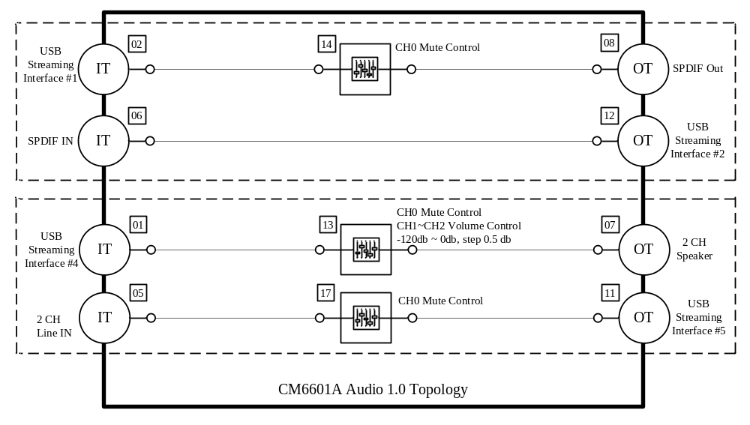

USB Interface List

 | Interface Description | Endpoint
Interface 0 | Audio Control Interface of Audio Device
Interface 1 | Audio Stream Interface for SPDIF Out | 0x06, 0x86(Feedback Endpoint)
Interface 2 | Audio Stream Interface for SPDIF In | 0x8A
Interface 3 | Audio Control Interface of Audio Device
Interface 4 | Audio Stream Interface for Speaker | 0x05, 0x85(Feedback Endpoint)
Interface 5 | Audio Stream Interface for Line In | 0x88
Interface 6 | HID Interface | 0x84(Interrupt In 16 bytes)
Interface 7 | Audio Control Interface of MIDI Device
Interface 8 | MIDI Stream Interface | 0x01(Bulk Out), 0x82(Bulk In)

High Speed Audio Stream Alternate Setting List

 | Alternate | Data Format | Sampling Rate
Interface 1  (SPDIF Out) | 1 | 2CH, 16Bits PCM | 32000, 44100, 48000, 88200, 96000
Interface 1  (SPDIF Out) | 2 | 2CH, 24Bits PCM | 32000, 44100, 48000, 88200, 96000
Interface 1  (SPDIF Out) | 3 | 2CH, 16Bits AC3 | 32000, 44100, 48000, 88200, 96000
Interface 2  (SPDIF In) | 1 | 2CH, 16Bits PCM | 32000, 44100, 48000
Interface 4  (Speaker) | 1 | 2CH, 16Bits PCM | 8000, 16000, 32000, 44100, 48000, 64000, 88200, 96000
Interface 4  (Speaker) | 2 | 2CH, 24Bits PCM | 8000, 16000, 32000, 44100, 48000, 64000, 88200, 96000
Interface 5  (Line In) | 1 | 2CH, 16Bits PCM | 8000, 16000, 32000, 44100, 48000, 64000, 88200, 96000
Interface 5  (Line In) | 2 | 2CH, 24Bits PCM | 8000, 16000, 32000, 44100, 48000, 64000, 88200, 96000

Full Speed Audio Stream Alternate Setting List

 | Alternate | Data Format | Sampling Rate
Interface 1  (SPDIF Out) | 1 | 2CH, 16Bits PCM | 44100, 48000
Interface 1  (SPDIF Out) | 2 | 2CH, 24Bits PCM | 44100, 48000
Interface 1  (SPDIF Out) | 3 | 2CH, 16Bits AC3 | 44100, 48000
Interface 2  (SPDIF In) | 1 | 2CH, 16Bits PCM | 44100, 48000
Interface 4  (Speaker) | 1 | 2CH, 16Bits PCM | 44100, 48000
Interface 4  (Speaker) | 2 | 2CH, 24Bits PCM | 44100, 48000
Interface 5  (Line In) | 1 | 2CH, 16Bits PCM | 44100, 48000
Interface 5  (Line In) | 2 | 2CH, 24Bits PCM | 44100, 48000

